To: Engineering Communications

From: Patrick Austin (10-1)

Date: April 14, 2017

Subject: K-12 Project Proposal, Rough Draft

**Methods**

*By: Patrick Austin*

Simply Machines is a hands-on activity designed to introduce the concept of work in physics. Team 10-1 has designed Simply Machines around Next Generation Standards K-2 ETS-1-1, pertaining to the use and design of tools to solve simple problems, in order to satisfy Washoe County Core Curriculum standards. Having prepared an instruction manual, Team 10-1 has assembled a complete lesson package for the Simply Machines project which will utilize that manual. This lesson package is designed to provide support and information for teachers who wish to introduce students to basic physics concepts such as work.

**Lesson Plan**

The lesson plan, included as Appendix A, details the goals, procedures, and means for assessment included in the Simply Machines project. The lesson plan was created to encourage students to ask questions, observe, and gather information about situations where the creation or improvement of a tool could help solve a problem. This is in accordance with Next Generation Standards K-2 ETS-1-1 [Next Gen Science, website]. The lesson plan begins with a review lesson covering the basic concept of work and how simple machines are used to do work. As students are likely to have used many of these tools to do work without realizing the physics principles involved, this lesson is designed to promote association with real-world problems. Once students have been introduced to the topic, demonstrations of operation of each machine are shown and the group work begins.

The lesson plan also addresses likely questions and issues that can be expected to arise during group work with appropriate answers and suggestions. The lesson plan concludes with guidance on assessment, so as to measure student understanding and success of the project.

**Student Instructions**

Students are encouraged to think about simple machines as an engineer might during the group work stage of the Simply Machines project. Team 10-1 guided students towards a basic application of the engineering design process, as shown in Fig. 1, in considering how tools can be used and improved to suit particular situations.

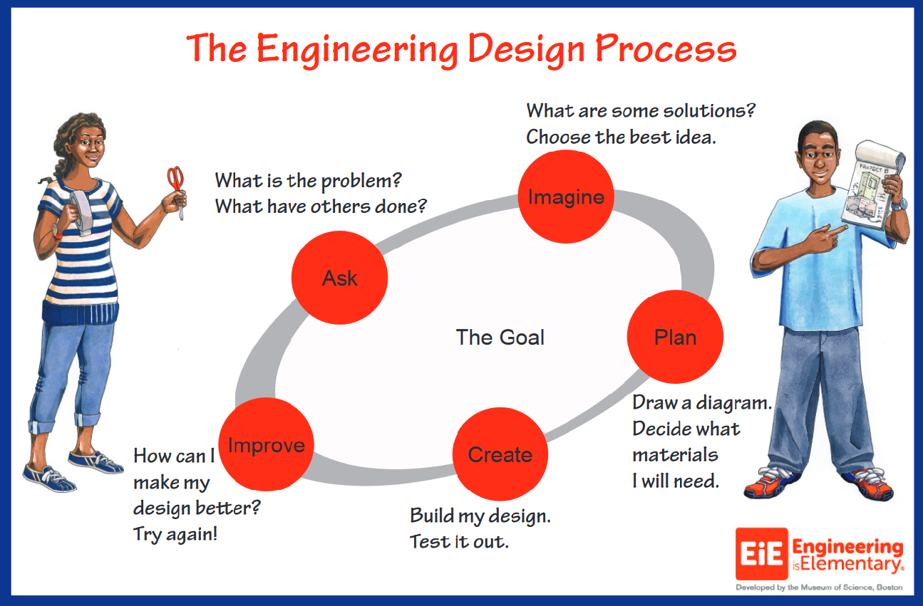

Fig. 1: This diagram shows the engineering design process at a level of complexity appropriate for second grade students. During the group discussion phase, facilitators are encouraged to ask questions about the simple machines that are inspired by the engineering design process [EIE, website].

Having been shown examples of pulleys, levers, and wheel and axle systems, students were encouraged to brainstorm real-world applications of these tools, their limitations, and potential improvements that might make the tools better suited to a given problem. Difficulties that arise in the operation of the machines present opportunities to encourage students to think about how tools can be modified and improved.

**Classroom Visit Set-up**

The Simply Machines project has been designed to accommodate a variety of teaching spaces, including those that have limited desk or floor space. Team 10-1 was able to adapt the classroom to their needs by scheduling classroom preparation time into the lesson so as to organize stations where each simple machine unit could be demonstrated. During the introductory lesson, students convened as one group in the center of the class. Afterwards, students participated in each simple machine unit in circular groups, which facilitated discussion and feedback on design and use of the machines.

**Assessment**

The Simply Machines project incorporates three metrics for assessment of student learning and engagement. First, during the group work phase of the project, teachers are encouraged to get direct feedback from students about their engagement with and understanding of the material, and to tailor their demonstration of the simple machine to address issues of understanding that arise. Second, a group question and answer session after the group work phase helps clarify remaining questions, cement concepts and core definitions, and give a final emphasis to the engineering design process. Finally, a written assessment is given to the students which is designed to measure understanding of definitions and concepts introduced in the project. These measures are designed to give teachers metrics to analyze the success of the exercise. Further information on these means of assessment and Team 10-1’s results are provided in the analysis section.

Appendix A  
Lesson Plan  
(By: Patrick Austin)